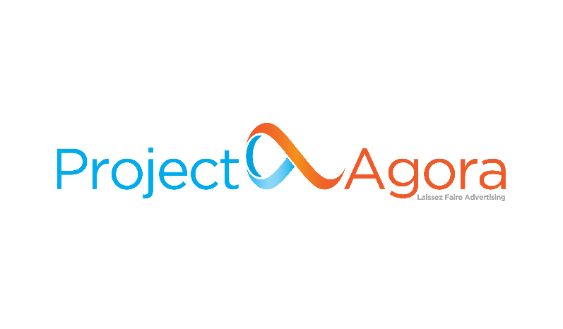

**Advertiser Success Executive**

[**Project Agora**](http://www.projectagora.com/), a [**TDG (ThinkDigital Group)**](https://thinkdigitalgroup.net/) company, is a Media Technology SaaS on a mission to keep the **Open Web Open**. In our day-to-day, we work with over 2700 top local digital Publishers and e-Retailers in EMEA and LATAM, supporting them to maximize the value of each visitor.

Project Agora has been named as one of the 1.000 fastest growing companies in Europe by the Financial Times, enjoying an annual growth of more than 80% every year since 2017. Our teams are an extraordinary group of talented, active, and innovative people who care about more than just building cutting edge technology. We live and define our work ethics by our core values. We are **Rainmakers** bringing stunning results, **I+Valuers** supporting colleagues, customers and partners and **Fat Cow Killers** striving to take inefficiency out of the way. Innate **Curious** we always explore ways to understand root causes and innovate and **Positive Bigfoots** carrying self-sustainable digital minded happiness to other people.

**Your Impact**

To deliver on our noble mission, we are looking for a highly motivated **Advertiser Success Executive** to join our **Project Agora Campaign Operations Team**. You’ll join an established and fast-paced environment with the main focus on providing solutions to Advertisers that activate and grow their leads and reach their KPIs. Within our growing organization, you will have the opportunity to work at the forefront of the advertising industry and become part of one of the leading Ad-Tech & Programmatic Advertising companies in EMEA and LATAM.

As an Advertiser Success Executive, you will be responsible to provide accurate solutions to our Advertisers and act with a key role in growing clients’ business.

Being part of a fast-growing scale-up organization, the role requires a passionate, self-starter and team-player professional with the ability to contribute to our business growth.

The successful candidate will join the Campaign Operation Team and will be based in TDG’s Tech Hub in Patras.

Come join us and help keep the Open Web Open.

**Key Responsibilities**

* Programming & management of digital advertising campaigns across different channels, with a focus on optimization and data analysis to meet customers’ delivery & performance KPIs.
* Liaising with clients for providing continuous training, support and consulting on our digital advertising products and services to maintain ongoing relationships.
* Manage individual deliverables and meet our team’s KPIs.
* Work with internal and external teams in order to provide solutions.
* Analyze the campaigns' performance and conversions.
* Propose and execute A/B split testing scenarios as well as analyze the results.

**We’re looking for someone who**

* Holds a Bachelor’s Degree in Computer Science, Information Systems, Business Administration or another related field. Master would be considered a plus.
* Has 2-3 years working experience in eCommerce, digital advertising industry.
* Is fully developed Customer Service Skills.
* Provides a strong business acumen to understand the business challenges that our solutions address.
* Is able and experienced in using web applications for a professional purpose. Familiarity with web technologies and languages including HTML, CSS, JavaScript would be considered a plus.
* Can prioritize and deliver within strict deadlines.
* Has excellent communication skills in Greek and English, both written and verbal.
* Prioritizes features & solutions according to value & effort, in collaboration with Product and Business departments.
* Can be a voracious learner, having the desire and ability to become a deep expert in hundreds of use cases across multiple products.

**Who you will be working with**

* A team with a great working culture that embraces autonomy and initiative-taking, supporting local media owners against international goliaths.
* A highly skilled engineer and business team organized in a specific structure, interacting with numerous UIs and tools.
* Sales and Product teams, in order to provide feedback on our campaigns & products.

**Personal Objectives**

* Gain deep knowledge of our products covering hundreds of use cases and offer excellent customer services.
* Develop communication skills to efficiently provide our Advertisers with your feedback.
* Become an expert in learning new products and ad technologies.

**Benefits and Perks**

**Project Agora** company is part of **TDG**, recognized as a [**Great Place to Work® for 2022**](https://www.greatplacetowork.gr/certified-companies/thinkdigital-group/). We are on a mission to boldly lead our people to where no one has gone before. Our people enjoy benefits that make them able to develop their careers and professional skills. We challenge ourselves to work with the best and most talented professionals and we want to offer a great place to work and thrive. We are offering:

* A competitive salary based on experience and skills.
* A budgeted training and professional development plan.
* A modern workplace environment, and the excitement of working closely with a successful, highly motivated, dynamic, and talented team.
* Heart Long Weekends! A paid-time-off throughout the year to enjoy life outside of work.
* Health insurance scheme.
* Access to TDG’s Library for professional development.
* Fresh fruits & best selection of tea every day.

**Additional Information**

* Τype: **Full-time**
* Seniority Level: **Junior**
* Reports to: **Advertiser Success Manager**
* Location: **Patras, Greece / Hybrid**

Project Agora offers a hybrid working model. Team members all over the EMEA region currently can meet in person every other week. Project Agora continues to grow our team by conducting a remote-first onboarding process.

**You can apply for this job at the link** [**here**](https://tdg.bamboohr.com/jobs/view.php?id=186)**.**

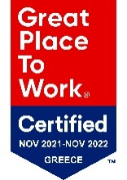TDG is certified as one of the great  
working environments in Greece for 2022.

Read more [here](https://thinkdigitalgroup.net/tdg-has-been-certified-as-a-great-place-to-work-for-2022/)