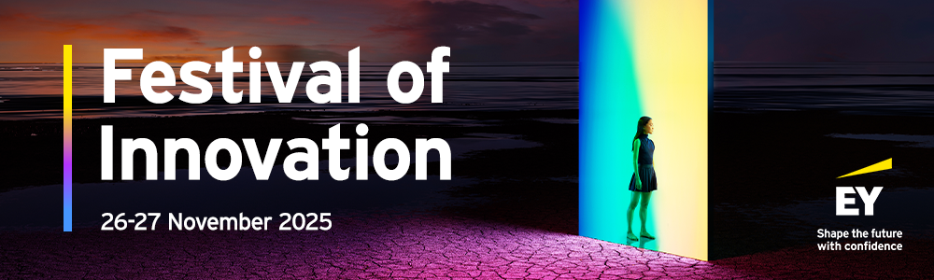
Dear future participant,
Are you ready to explore the exciting world of technology? At EY, we believe that technology can help us build a better working world for everyone.
We are pleased to invite you to join us for an inspiring two -day event featuring some of our exceptional Tech talents. This is your chance to gain valuable insights into a technology career within EY and discover how you can make a meaningful impact in this dynamic field!
What to expect:
- Meet inspiring leaders: connect with the people who are leading innovative tech projects and breaking barriers in the industry
- Learn and grow: hear firsthand experiences and gain insights into the diverse paths a technology career can take you
- Be part of the change: discover how you can contribute to building a more inclusive and equitable tech landscape
- After the session, you’ll receive your certificate

Join us in celebrating the power of diversity in technology and take the first step towards an exciting career at EY!
Event details:
- Date: 26-27 November (3 PM – 6 PM CET)
- Location: Microsoft Teams

Take advantage of this opportunity, reserve your spot today via EY | Festival of Innovation.



© 2025 EY. All Rights Reserved
EY refers to the global organization, and may refer to one or more, of the member firms of Ernst & Young Global Limited, each of which is a separate legal entity. Ernst & Young Global Limited, a UK company limited by guarantee, does not provide services to clients. Information about how EY collects and uses personal data and a description of the rights individuals have under data protection legislation are available via ey.com/privacy. EY member firms do not practice law where prohibited by local laws.
For more information about our organization, please visit ey.com.

